

Company Fact Sheet
March 2010

Premier Power Renewable Energy, Inc. (OTCBB: PPRW) is a leading global integrator of solar photovoltaic systems for commercial, utility, government and residential applications. Premier provides integrated solar solutions through its EPC++ business model, which includes the engineering, procurement, construction, project development and project financing for large-scale photovoltaic solar projects in the U.S., Spain and Italy. Premier’s engineering expertise has resulted in their leadership in multiple market segments, including the distributed generation market in Spain, centralized generation market in Italy and the U.S. commercial and utility markets.

Premier Power Is Well Positioned In Both Established And Nascent High-growth Markets

Spain: Continued growth in retail (rooftop) sector
- Government cap of 500MW/yr for 2009-20011 should not affect our business
- Our engineering expertise in US has helped us become a market leader in the Spain retail market
Company Information
Headquarters El Dorado Hills, CA
Founded 2001
Number of Employees 85
Fiscal Year End December 31
International Offices Madrid, Spain
Pamplona, Spain
Campo Basso, Italy
2008 Revenue $44.2MM, up 165% Y/Y
2008 Net Income $569,000 or $0.02 EPS

Stock Information (As of March 1, 2010)
Last Trade 2.50
52-Week Price Range 1.50 - 8.00
Shares Outstanding 29.05M
Market Capitalization 72.6M
Italy: Emerging wholesale sector
- Italy now world’s most attractive feed-in-tariff rates at €0.36-0.49/kWh; Government guaranteed for 20 years
- In addition to feed-in tariff, government will guarantee purchase of system electrical output for approx. €0.10/kWh or higher, depending on the region
- Government stated goal of cumulative power installed: 3,000 MW by 2016 to avoid E.U. sanctions
- We will use our Spanish expertise to follow in to Italian retail (rooftop) market
U.S.: Emerging markets outside of CA
- Advantageous state policies in several east coast markets:
  - NJ, PA, MD, MA, NC, GA, FL
- Emerging wholesale sector in CA and east coast states
- We will use our Italian expertise to exploit wholesale market opportunities in the U.S.

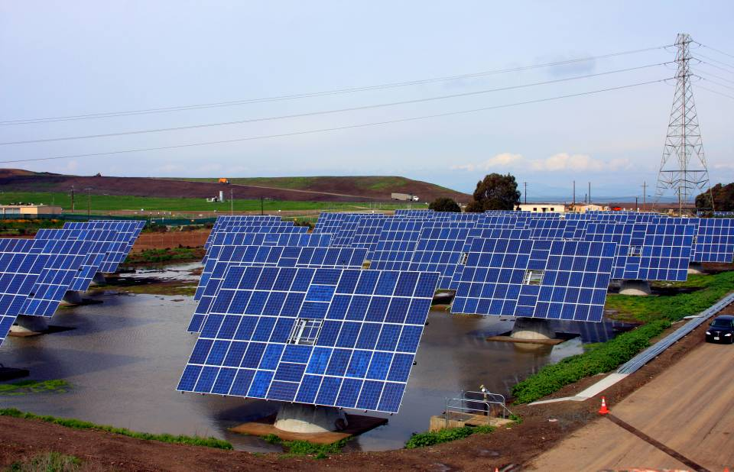
Premier Power is a turnkey solar system integrator. We’re there for the entire process – conducting site surveys, pulling building permits, ordering solar components, installing systems, and finalizing paperwork for rebates. Premier Power sees the job through from start to finish.
← Premier Power Installation – Bi-directional Trackers.
The largest system of its kind in North America.

Ther
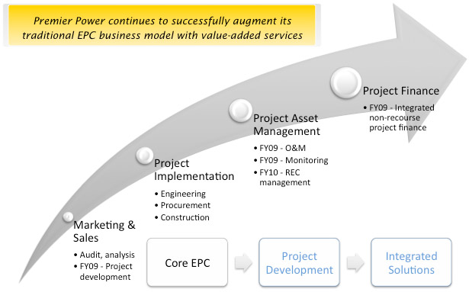
Recent Company News
- Nov. 2009 – Premier Power announces that is has broken ground on its first mega watt in Italy. The project is part of the series of solar projects, valued in excess of $100 million, which are being developed as a result of Premier’s acquisition of Arco Energy in July 2009.

- Sept./Oct. – Signs contracts for 1MW of Solar Rooftop Installations in Spain.

- Sept. – Breaks ground on first phase of it 20MW solar pipeline in Southern Italy
- July – Acquires Arco Energy, a privately held solar project developer, EPC and distributor based in Italy with more than 20 mega watts of permitted projects worth approximately $114 million in potential revenue
PV market in 2008 @ costs of US$ 0.25 to 0.35/kWh
- March – Reports financial results for the fiscal year and fourth quarter ended December 31, 2008 including total full-year revenue of $44.2 million, a 165 percent increase over fiscal 2007, while maintaining profitability
PV addressable market @ costs of US$ 0.08 to 0.12/kWh
Photovoltaic (PV) Market Opportunity

10GWp =
$5.6 Billion
1,500 GWp =
$8.4 Trillion

)
- March – Elects former Southern California Edison executive and Government and public affairs expert Tommy Ross to its board of directors

Management Team
Dean R. Marks President/Chief Executive Officer
Frank Sansone Chief Financial Officer
Miguel de Anquin Chief Operation Officer
Stephen Clevett Executive Vice President

Contacts
Investors:
Charles Messman
Todd Kehrli
MKR Group, Inc.
(323) 468-2300
pprw@mkr-group.com


The information contained herein was obtained from the management of Premier Power Renewable Energy, Inc. and other sources we believe to be reliable. This does not constitute a solicitation of the purchase or sales of securities. MKR Group, Inc., is employed by Premier Power Renewable Energy, Inc. as investor relations counsel. This Fact Sheet may contain statements relating to future results of the Company (including certain projections and business trends) that are “forward-looking statements” as defined in the Private Security Litigation Reform Act of 1995. Actual results may differ materially from those projected as a result of certain risks and uncertainties, including but not limited to, changes in political and economic conditions, demand for and market acceptance of new and existing products, as well as other risks and uncertainties detailed from time to time in the filings of the Company with the Securities and Exchange Commission.

